MU Shiying 穆時英 (1912-1940)

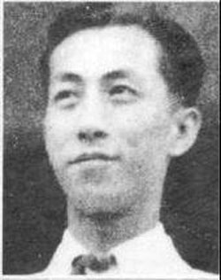

Figure 1 [Image taken from http://www.royalasiaticsociety.org.cn/v/index.php?option=com_content&view=article&id=74:forthcomingtitles&catid=41:monograph-series&Itemid=95]

A leading member of the Shanghai-based New Sensationist Movement (*xin ganjuepai*), Mu Shiying is best known for a set of short stories he wrote in the early 1930s. Typically set in the modern and Westernized setting of Shanghai’s foreign concessions, Mu’s stories usually feature a disjointed, syncopated writing style, an abundance of aural and other sensory descriptions, together with a fascination with modern Western culture and all of its trapping. Many of his stories employ experimental narrative techniques such as interior monologue and stream of consciousness, and frequently explore the symbolics of female eroticism and commodity culture. Altogether, Mu published around fifty stories, many of which were published or reprinted in four single-authored collections. At different points in his life, Mu had links to Chinese Communism, Nationalism, as well as the Wang Jingwei Japanese puppet regime. At the same time, he was also variously attacked by both the League of Left-Wing Writers and by the Nationalists. In 1940, at the age of twenty-eight, Mu was assassinated by Nationalist agents.

Born in Shanghai in 1912, Mu Shiying was the son of a banker and a socialite. In 1929, Mu enrolled in the Western Literature department of Shanghai’s Guanghua University (which in 1951 merged with another university, and is now known as East China Normal University), and it was in that same year that he began writing short stories. In 1930, he published his first story, “Our World” (*Zanmen de shijie*), together with other stories including “Black Whirlwind” (*Hei xuanfeng*) and “Poles Apart” (*Nan beiji*), which would subsequently be adopted as the title story of his first volume of fiction (first published in 1932, with expanded edition published in 1933). Mu’s early stories adopted the voice of the proletariat, and some were explicitly influenced by the classic Ming dynasty novel of outlaws, *Water Margin* (*Shuihu zhuan*).

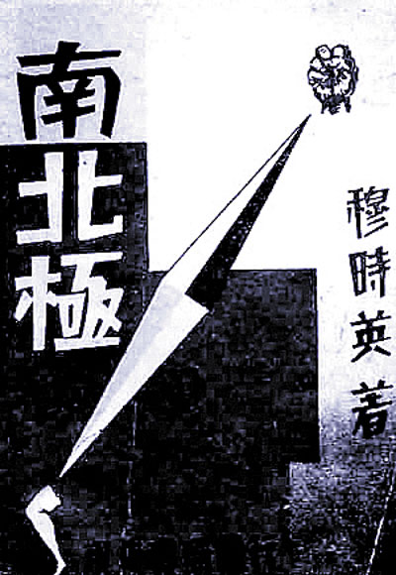

Around 1932, Mu Shiying began developing close ties with authors associated with China’s nascent New Sensationist Movement, most notably Shi Zhecun, Liu Na’ao, and Dai Wangshu. The movement was loosely inspired by a similarly-named literary movement in Japan in the late 1920s, and both the Japanese and Chinese variants of the movement were strongly influenced by early twentieth century Western modernism. These influences are clearly in evidence in the works included in Mu’s second short story collection, *Public Cemetery* (*Gongmu*) (1933), which includes influential stories such as “Shanghai Foxtrot,” “Five in a Nightclub,” and “Black Peony.” Of these, “Shanghai Foxtrot” was originally conceived as a fragment of a projected novel to be entitled *Shanghai 1931*, but ended up being released on its own as a technical exercise. The story follows a variety of different characters, from diverse social stations, as they roam through Shanghai, which is described in the story as “a heaven built on hell.” Adapting cinematic techniques of montage, the presents a kaleidoscopic array of loosely-connected glimpses of Shanghai’s nightclubs, department stores, and hotels. “Five in a Nightclub” similarly adopts a disjointed narrative style to follow the stories of five unrelated characters in different locations on the same afternoon, who eventually coincide within the space of a Shanghai nightclub.

Figure 1 Cover of the original edition of *Poles* Apart. Taken from http://shszx.eastday.com/node2/node4810/node4851/wswh/u1ai56062.html

In the preface to *Public Cemetery*, Mu notes that many of the stories in the collection were driven by a fascination with the figure of the “Pierrot”—a reference to the traditional clown figure in the Commedia dell’Arte, but which Mu redeploys as a picaresque, downtrodden figure (either male or female) symbolizing a spirit of passive resistance to institutionalized power. In fact, in 1934, the year after *Public Cemetery*, Mu composed a story along these lines that was itself entitled “PIERROT” (no Chinese title), and which was also subsequently included in his third short story collection, *White Platinum Statue of a Woman* (*Baijin de nüti suoxiang*), also published in 1934.

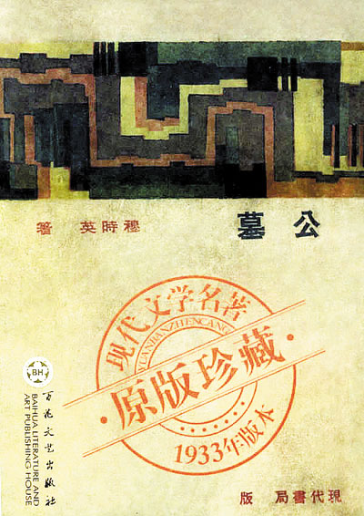Several of the stories published in *White Platinum Statue of a Woman* feature an imaginative exploration of the symbolism of the modern women and of the female body. The title story of the collection, for instance, describes a doctor’s examination of the naked body of a statuesque female patient, which gradually ignites his own sexual desire. Another story in the collection, entitled “Camel, Nietszchean, and Woman” (*Luotuo, Nicaizhuyizhe yu nüren*), opens with a quote from Nietzsche’s *Thus Spoke Zarathustra* comparing the spirit to a camel, and then segues into a description of the Camel-brand cigarette the male protagonist as he wanders through the city. The protagonist meets a hyper-modernized women, whom he criticizes for not knowing how to drink coffee and smoke cigarettes, but who then proceeds to instruct *him* in the intricacies of 373 cigarette brands, 23 different varieties of coffee, and 5,000 kinds of mixed drinks. My continues to develop similar concerns in his final collection of short stories, *The Affection of St. Virgin* (*Sheng chunü de ganqing*) (1935).

Figure 2 Cover of original edition of *Public Cemetery*. Taken from http://shszx.eastday.com/node2/node4810/node4851/wswh/u1ai56062.html

In the final years of his life, Mu’s political affiliations became increasingly complicated. In 1935 he began working as the editor for a Nationalist-controlled newspaper, *The Morning Post*, and in the latter half of the decade he developed increasingly close personal, cultural, and political ties with the Japanese, to the point of working for the Wang Jingwei Japanese puppet regime. In 1940 he was assassinated by the Nationalists, under ambiguous circumstances.

**Short Story Collections:**

*Poles Apart* (*Nan beiji*南北極) (1932) [Expanded edition published in 1933]

*Public Cemetery* (*Gongmu*公墓) (1933) [Includes “Shanghai Foxtrot”]

*White Platinum Statue of a Woman* (*Baijin de nüti suoxiang*白金的女體塑像) (1934) [Includes “Camel, Nietszchean, and Woman”]

*The Affection of St. Virgin* (*Sheng chunü de ganqing*圣处女的感情) (1935) [The final collection of short stories Mu Shiying published in his lifetime]

*The Complete Stories of Mu Shiying* (*Mu Shiying xiaoshuo quanji*穆時英小說全集) (1997) [Published in two volumes]

Recommended Reading:

Lee, Leo Ou-fan, *Shanghai Modern: The Flowering of New Urban Culture in China: 1930-1945*, chapt. 6.

Shih, Shu-mei, *The Lure of the Modern*: Writing Modernity in Semi-Colonial China, 1917-1937, chapt. 11

Andrew Field, *Mu Shiying: China’s Lost Modernist—New Translations and an Appreciation* (2013)